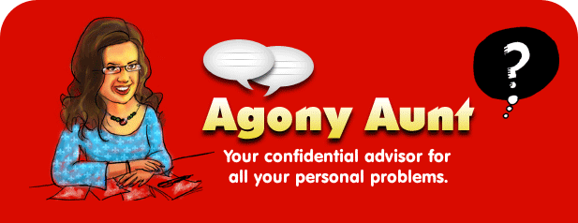

- An ‘agony aunt’ is somebody who you don’t know personally, who you can write to for general advice about life and relationship problems. The correspondence is usually published in a magazine or newspaper where other readers, apart from the one who wrote in, can benefit from the wisdom.

- Now Write an email reply to this email:
Hi
I’m really insecure about my exam and I’m feeling very nervous.
Have you got any advice?
Laurie.

- Think of pieces of advice for Laurie- both things you think she should and shouldn’t do. Why would you recommend doing/not doing these thing?
- Include the USEFUL LANGUAGE for recommending and suggesting.
- You have an extra file with extra useful expressions. Use some of them!!!
- DO IT IN WORD, PLEASE.

