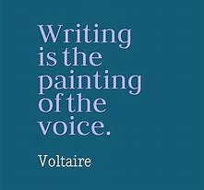

- Read the WRITING BANK which includes useful language and expressions in more formal reports. Use an appropriate formal style and expressions from it.

- Have a look at the model text and additional tips on page 160. It’ll help you.

- Remember the 4 paragraphs, write between 120 and 200 words, no more, take a picture and send it to me.

- DO IT IN WORD, PLEASE.

